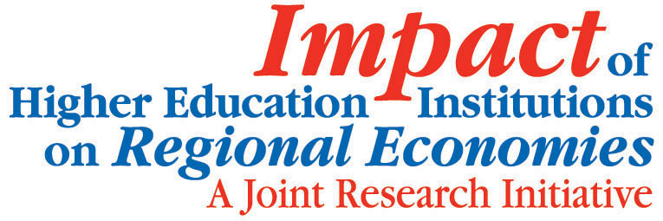
Higher Education – An Engine for Growth
Venue:
Department for Employment and Learning
39/49 Adelaide Street
Belfast BT2 8FD
Wednesday 2nd February 9.30am – 13.15pm
10am Welcome from the Chair
Fergus Devitt, Director Higher Education, DEL
10.05am Overview
Ursula Kelly
Impact of Higher Education Institutions on Regional Economies Research Initiative Joint Coordinator

This brief presentation will give an overview of the wide range of research that was undertaken as part of the Impact of Higher Education Institutions on Regional Economies research venture.
10.15am The Myth of the Ivory Tower: the Connectivity of UK Academia with the Business, Public and Third Sector – Evidence from Northern Ireland and the rest of the UK
Michael Kitson, Cambridge University
COFFEE BREAK: 11.15am
11.30am The Impact of Higher Education Institutions on the Northern Ireland Economy
Peter McGregor, University of Strathclyde
12.30pm Closing remarks
Fergus Devitt
Lunch: Buffet Lunch available from 12.30pm

